**Monitoring Water Stress over Agricultural Area using Satellite-Derived Indices**

**Abstract**

Drought is a natural phenomenon where there is a prolonged period of abnormally low precipitation, leading to water scarcity and significant impacts on ecosystems, agriculture, and communities. India experiences the majority of its annual rainfall during the south west monsoon period (June-September) and this is also the period of Kharif season. The erratic nature of monsoon, characterized by prolonged dry spells and elevated temperatures affects the crop cultivation during the season, and is a primary factor contributing to droughts.This study aims to find drought-like conditions over the study areas . Five districts of India are chosen as study areas: Bidar of state Karnataka, Parbhai of State Maharashtra, Gulbarga of state Karnataka, Balangir of state Odisha, Ananthapur of state Andhra Pradesh. These are the districts of Indian states where agriculture areas mostly get influenced by droughts.. Remote-Sensing data provides information about the Earth surface, which include information about the agricultural areas and different indices responsible for drought. For all these provinces we have used MODIS(Moderate Resolution Imaging Spectroradiometer) satellite data based on NDVI and NDWI products. The results obtained in the study can be used to seek out conditions like drought. This study aims to detect crop water stress by remote sensing indices like NDWI , NDVI and NDDI which we mostly use to find drought-like conditions.

**Introduction:**

India is a vast country in geographical terms with various regions experiencing different climate conditions. This is also reflected in the distribution of rainfall in India. Some of the Regions receive very excessive rainfall (Southern and Northeastern parts) while others receive very low rainfall (northwestern and western region). This Seasonal rainfall is crucial for agriculture activities, as it provides the necessary moisture for crop cultivation, influences planting and harvesting seasons, and contributes to the general well-being and efficiency of ecosystems across India. In India most of the Parts of Tamilnadu, Karnataka, Andhra Pradesh, Eastern Rajasthan, South - Western Uttar Pradesh comes under Low rainfall category (60 cm to 100 cm) And Other region Northern Andhra Pradesh, eastern part of Maharashtra, Madhya Pradesh, Odisha, some parts of Jammu and Kashmir come under moderate rainfall category (100cm to 200cm). And Drought is most likely to happen in those parts of India where rainfall is very less or average. Drought is a period of dried- than normal 1 conditions that results in water-related problems. The amount of precipitation at a particular location varies from year to year, but the average quality is relatively consistent over time.

1. **Indian Summer Monsoon Rainfall (ISMR):**

The Indian subcontinent's socioeconomic landscape is shaped by the **Indian Summer Monsoon Rainfall (ISMR),** a climatic phenomenon of great significance. The Indian Summer Monsoon Rainfall (ISMR), which is characterized by the seasonal reversal of winds and the ensuing heavy rains, usually lasts from June to September. This is an important time for India's agricultural sector, water resources, and general way of life. The effects of the monsoon vary according to the different parts of India. It begins in the southwest and moves slowly up the country's coast to the north and central areas. Due to this geographic diversity, rainfall falls in different patterns, which in turn affects cropping strategies and other agricultural practices.

India is a vast country in geographical terms with various regions experiencing different climate conditions. This is also reflected in the distribution of rainfall in India. Some of the Regions receive very excessive rainfall (Southern and Northeastern parts) while others receive very low rainfall (northwestern and western region). This Seasonal rainfall is crucial for agriculture activities, as it provides the necessary moisture for crop cultivation, influences planting and harvesting seasons, and contributes to the general well-being and efficiency of ecosystems across India. In India most of the Parts of Tamilnadu, Karnataka, Andhra Pradesh, Eastern Rajasthan, South - Western Uttar Pradesh comes under Low rainfall category (60 cm to 100 cm) And Other region Northern Andhra Pradesh, eastern part of Maharashtra, Madhya Pradesh, Odisha, some parts of Jammu and Kashmir come under moderate rainfall category (100cm to 200cm). And Drought is most likely to happen in those parts of India where rainfall is very less or average.

There are **dry spell** and **wet spell** phases during the monsoon season, each with unique consequences. Dry spells, which are characterized by low rainfall, can cause crop failures, drought conditions, and a lack of water, especially in areas where agriculture is dependent on rain. Wet spells, on the other hand, bring heavy rains, which can occasionally cause landslides, flooding, and damage to infrastructure. Both rural and urban communities must adapt to these fluctuations by implementing effective disaster management strategies.Different rainfall patterns brought about by diversity have an impact on cropping patterns and agricultural practices.

Based on ISMR patterns, the productivity of the highly monsoon-dependent Indian agricultural sector varies significantly. During the monsoon season, crops require a sufficient amount of rainfall that is evenly distributed to ensure adequate soil moisture and irrigation for a successful harvest. On the other hand, irregular or insufficient rainfall can lead to lower crop yields, food insecurity, and financial difficulties for farmers. The agricultural calendar is shaped by the timing and intensity of the monsoon, which also affects food production, prices, and supply chains across the country. The monsoon directly affects sowing, cultivation, and harvesting schedules.

The intricate interactions between nature, society, and economy are encapsulated by the Indian Summer Monsoon Rainfall, which highlights the significance of innovative agricultural practices, climate resilience, and sustainable water management in the face of changing climatic patterns.

1. **Agriculture in India:**

India's agricultural sector is as varied as the nation's topography, with a wide range of crops grown all over the place. India has an unmatched diversity of crops, each suited to flourish in a particular set of environmental conditions, thanks to its numerous agro-climatic zones, which range from dry deserts to tropical rainforests. Staple crops such as rice, wheat, and sugarcane thrive in the fertile plains of the Indo-Gangetic region, providing the foundation for the food security of the nation. As one moves south, the Deccan plateau grows a wide variety of crops to meet the dietary needs and cultural customs of the region, such as oilseeds, pulses, and millets. Coastal areas utilize the abundance of the ocean, and fishing communities augment their incomes by pursuing coastal agriculture, raising crops that can withstand the salty environment, like coconut, cashew.Indian agriculture is heavily dependent on rainfed areas, which occupy 67% of the net sown area and contribute 44% of the country's food grain production. These rainfed areas support 40% of the population. Feeding India's growing population of 1.3 billion people by 2020 will require a significant increase in agricultural productivity, from the current 1 ton per hectare to 2 tons per hectare in rainfed areas. However, rainfed areas face various biophysical and socioeconomic constraints that limit productivity, including declining natural resource quality, poverty, and lack of infrastructure. To address these challenges, economically viable rainfed technologies and farming systems approaches are needed that can improve income, employment, and food security in these regions. Strategies such as forming self-help groups, using innovative extension tools, and taking a holistic farming systems perspective can help drive the adoption of improved rainfed technologies among farmers.

1. **Growth of crops in different Seasons:**

The growth of crops in India is intricately linked to the seasonal variations in rainfall, which influence planting, growth, and harvesting cycles. Here's a breakdown of how crops progress through different phases during the rainfall season:

3.1. Pre-monsoon Season (March-May):

* During the pre-monsoon season, farmers prepare their fields for sowing by plowing, leveling, and applying fertilizers.
* Early-maturing crops like pulses, oilseeds, and vegetables are sown during this period, taking advantage of residual soil moisture and the onset of summer heat.

3.2. Monsoon Season (June-September):

* With the onset of the monsoon rains, the main sowing season begins across India. The timing of sowing varies regionally, depending on the arrival of monsoon rains and soil moisture conditions.
* Rainfed crops such as rice, maize, millets, and cotton are typically sown during the early monsoon period, as they require ample moisture for germination and initial growth.
* Throughout the monsoon season, crops undergo different growth stages, including germination, vegetative growth, flowering, and fruiting, depending on their specific biological characteristics.
* Adequate and well-distributed rainfall during this period is crucial for crop development, ensuring sufficient soil moisture and nutrient availability.
* In regions with irrigation facilities, supplementary irrigation may be provided during dry spells to support crop growth and mitigate water stress.

3.3. Post-monsoon Season (October-November):

* As the monsoon begins to withdraw, the post-monsoon season marks the final stages of crop growth and maturation.
* Crops such as rice, maize, and pulses enter their reproductive stage, with flowering and grain filling occurring during this period.
* In some regions, the post-monsoon season coincides with the harvesting of kharif (monsoon) crops, including rice, pulses, and oilseeds, while in others, it may overlap with the planting of rabi (winter) crops like wheat, barley, and mustard.

3.4. Winter Season (December-February):

* During the winter season, rabi crops dominate agricultural activities in many parts of India.
* Rabi crops are sown towards the end of the monsoon season or during the early post-monsoon period, utilizing soil moisture retained from the monsoon rains and supplemented with irrigation where necessary.
* These crops undergo growth and development during the cool and dry winter months, with harvesting typically occurring in spring.

1. **Remote Sensing Indices** :

**4.1 NDVI ( Normalized Difference Vegetation Index) :**

The Normalized Difference Vegetation Index (NDVI) is a widely used numerical indicator that quantifies the presence and health of vegetation in a given area. It measures the difference between the reflectance of near-infrared (NIR) and red light wavelengths, providing valuable information about the density and vigor of vegetation cover.

**Formula:**

NDVI is calculated using the following formula:

***NDVI= (NIR+Red)/(NIR−Red)***

​Where:

* NIR is the reflectance in the near-infrared band.
* Red is the reflectance in the red band.
* The values of NIR and Red are typically normalized to fall within the range of 0 to 1.

**Range:**

* NDVI values range from -1 to 1, with specific interpretations for different ranges:
* Negative Values: Negative NDVI values typically indicate non-vegetated or water-covered surfaces. These areas reflect more visible light than near-infrared light.
* Values Close to Zero: Near-zero NDVI values are associated with barren or sparsely vegetated areas, such as deserts or urban areas, where the reflectance in both the red and near-infrared bands is low.
* Values Between 0 and 0.2: These values generally represent sparse vegetation, such as shrubs or grasslands.
* Values Between 0.2 and 0.5: Moderate NDVI values indicate dense vegetation cover, such as forests, croplands, or healthy grasslands.
* Values Above 0.5: High NDVI values are typically associated with dense and healthy vegetation, such as tropical rainforests or agricultural areas with abundant vegetation.

**4.2 NDWI (Normalized Difference Water Index):**

The Normalized Difference Water Index (NDWI) is a spectral index used to detect the presence and abundance of water bodies within a given area. It measures the difference in reflectance between near-infrared (NIR) and green light wavelengths, making it particularly effective for identifying water bodies amidst other land cover types.

**Formula:**

NDWI is calculated using the following formula:

***NDWI=(SWIR-NIR)/(SWIR+NIR)***

Where:

* *NIR* is the reflectance in the near-infrared band.
* Green is the reflectance in the green band.
* Similar to NDVI, the values of NIR and Green are typically normalized to fall within the range of 0 to 1.

**Range:**

NDWI values also range from -1 to 1, with specific interpretations for different ranges:

* Negative Values: Negative NDWI values typically represent non-water surfaces, such as vegetation or bare soil. In these areas, the reflectance in the green band is higher than in the near-infrared band.
* Values Close to Zero: Near-zero NDWI values may indicate sparse vegetation or dry soil, where there is minimal contrast between the reflectance in the green and near-infrared bands.
* Values Between 0 and 0.2: These values often represent mixed pixels with a combination of land cover types, including vegetation, soil, and some water bodies.
* Values Between 0.2 and 0.5: Moderate NDWI values indicate the presence of water bodies, such as lakes, rivers, or ponds, with relatively low reflectance in the green band and high reflectance in the near-infrared band.
* Values Above 0.5: High NDWI values suggest the presence of large and deep water bodies, such as oceans or deep lakes, with strong absorption of green light and high reflectance in the near-infrared band.

**4.3 NDDI(Normalized Difference Drought Index):**

In this study NDDI is used to find out the Drought severity for the past few years. NDDI is a drought sensitive index . The calculation of NDDI involves other indices NDVI and NDWI. Both Indices are mentioned above both of indices are sensitive to vegetated area and Water area respectively.

The formula to calculate the NDDI value –

***NDDI = (NDVI − NDWI)/ (NDVI + NDWI)***

where,

NDVI = Normalized Difference Vegetation Index ,

NDWI = Normalized Difference Water Index,

The drought Severity calculated based on the NDDI index is based on five classes namely very low, low, medium, high, and very high. Explained in the table below

Table : Drought Severity NDDI Value

|  |  |  |
| --- | --- | --- |
| No. | NDDI Value | Drought Severity Class |
| 1, | Less than - 2 | Very low |
| 2. | -2 - 0.7 | Low |
| 3. | 0.7 - 1.25 | Medium |
| 4. | 1.25 - 3 | High |
| 5. | Greater than 3 | Very High |

**Materials and Methods :**

**Study Area :**

**Balangir** is a city and Municipality in Balangir district in the state of Odisha. Balangir is located at 20.72°N 83.48°E.Balangir is one of the drought prone districts of Odisha.Agriculture is the mainstay for this rural population of the district. Primary cultivation predominantly occurs during the kharif season.The area is predominantly cultivated with paddy, pulses (Arhar, Green and Black gram), and vegetables (potato, onion, garlic, turmeric, ginger, and seasonal varieties), alongside fruits like mango, coconut, and guava. Paddy dominates, covering 59,335 hectares, with rainfed and irrigated yields of 27.54 and 41.75 quintals per hectare respectively in the kharif season, and 45.37 quintals per hectare in the rabi season for irrigated paddy. Additionally, cereals, coarse cereals, pulses, oilseeds, fibers, vegetables, and spices occupy areas of 68,270 hectares, 610 hectares, 37,310 hectares, 6,880 hectares, 250 hectares, 17,440 hectares, and 1,900 hectares respectively in the district.

**Ananthapur** district is at the southwest of Andhra Pradesh. It is bounded by Karnataka to the west, Kadapa district to the east, the district of Chittoor to the South, and Kurnool district to its North.It is located between 13’-40’ and 15’-15’ Northern Latitude and 76’-50’ and 78’-30’ Eastern Longitude. It covers an area of 19130 sq kms.The groundwater scenario of Ananthapur district in Andhra Pradesh state is analyzed, as it’s an arid, drought-prone, low rainfall area with a high dependency on groundwater. Ananthapur’s economy centers around agriculture, with crops like groundnut, rice, cotton, maize, chillies, sesame, and sugarcane dominating the landscape. However, the district grapples with its status as one of Andhra Pradesh’s most disadvantaged areas, exacerbated by its scanty rainfall, which critically affects its agriculture, heavily dependent on monsoons.

**Bidar** district is the northernmost part of karnataka state in India. The latitude of Bidar, Karnataka, India is 17.920000, and the longitude is 77.519722. The Karnataka state’s Bidar district is considered one of the drought-prone districts because of inadequate rainfall and significant rainfall variation within 3 its geographical area. Bidar is also one of the Indian rural districts where agriculture plays a vital roll in the economy. About 65 percent of the working population mainly depends on agriculture. Bidar district has the advantage of growing a variety of field and horticultural crops owing to its varied soil and climatic conditions. Traditionally crops like redgram, green gram, black gram, soyabean, cowpea, groundnut, sunflower, sesamum etc. are grown under Kharif Rainfed situation.

**Kalaburagi** formerly known as **Gulbarga** is one of the districts of Karnataka in southern India. This district is situated in north Karnataka between 76°.04’ and 77°.42 east longitude, and 17°.12’ and 17°.46’ north latitude, covering an area of 10,951 km2 .The climate of the Gulbarga district is sub-tropical,semi-arid type with moderate to severe summer, moderate winter and having low erratic rainfall. The average annual rainfall is 800 mm and it is bimodal in nature by spreading over 6 months from June to November The climatic conditions of this district are relatively warm and dry and being drought tolerant crop Red gram and jowar are best suited for cultivation in Gulbarga district during kharif season.

**Parbhani** district is one of the eight districts in the Marathwada region of Maharashtra state of India. Parbhani district lies between 18.45 and 20.10 North Latitudes and 76.13 and 77.39 East Longitude. Climatically Parbhani district is located in rain shadow area or drought prone area. Soil of the district is comparatively of lesser quality, irrigation facilities are less, short and thorny forest patches etc. These factors contribute to the underdevelopment of agriculture in the district. During kharif season Jowar, Bajra, gram, tur, groundnut and oil seeds are the major kharif crops. During the Kharif season June to October the average annual rainfall is 804.4 mm .

|  |  |  |
| --- | --- | --- |
| Fig 1. Balangir district | Fig 2: Anantapur District | Fig 3: Bidar District |

|  |  |
| --- | --- |
| Fig 4: Gulbarga District | Fig 5. Parbhani district |

**2.2 Datasets Used:**

**2.2.1 IMD Gridded Rainfall Data**:

Indian Meteorological Department (IMD) provides New High Spatial Resolution (0.25 X 0.25 degree) Long Period (1901 - 2023) Daily Gridded Rainfall Dataset Over India. This data product has very high spatial resolution. The Unit of rainfall is in millimeter(mm)’The first data in the record is at 6.5N and 66.5E, the second is at 6.5N and 66.75E, and so on. The last data record corresponds to 38.5N and 100.0E. The yearly data file consists of 365/366 records corresponding to non leap/ leap years [5]. In this study we are using 34 years of gridded rainfall data.

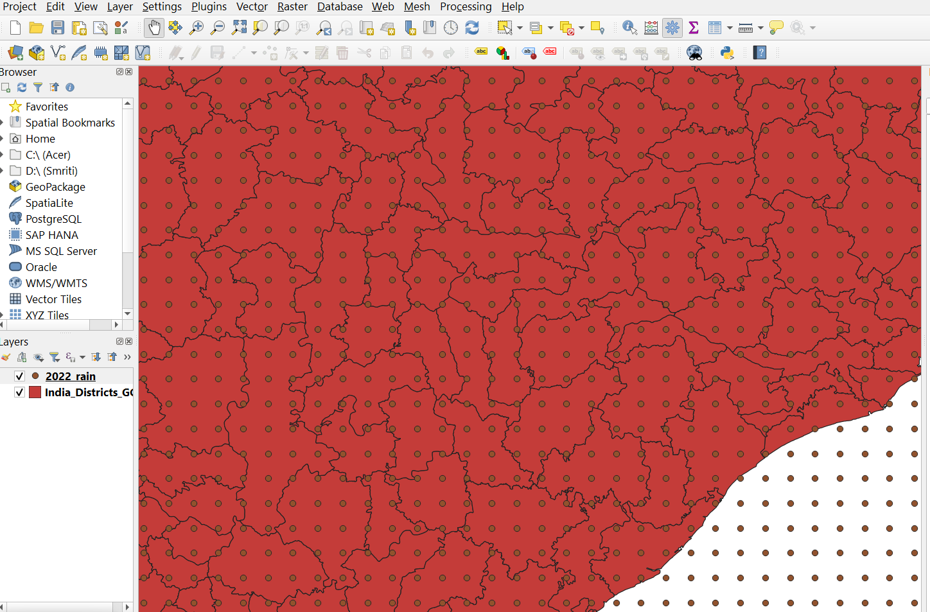

Fig 6: IMD Gridded Rainfall Data

**2.2.2 Shape Files**:

Shapefiles stores the location , geometry and attribution of point, line, and polygon features. Indian District wise shape file is used. The information provided by the shape files are State name , district inside the state , and the geometry(polygon or multipolygons).

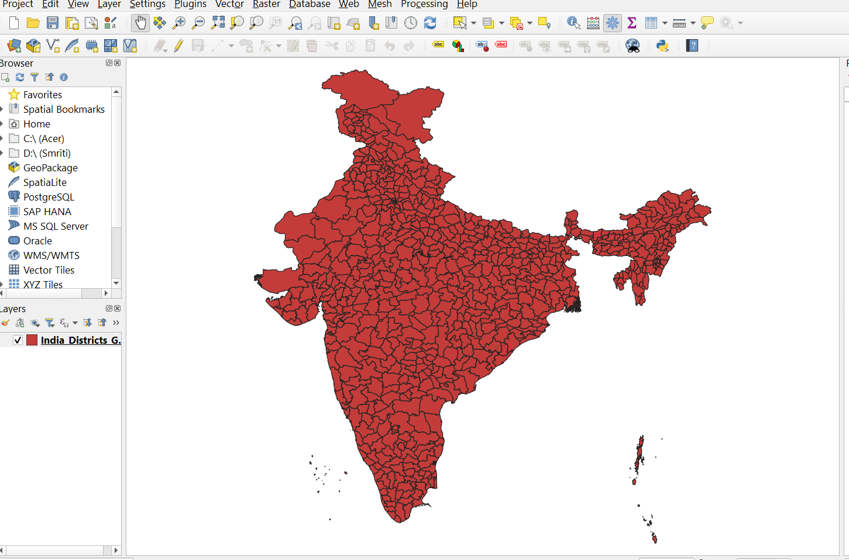

Fig. 7. District wise Shape File

**2.2.3 MCD12Q1.061 MODIS Land Cover Type Yearly Global 500m:** **(**[**Link**](https://developers.google.com/earth-engine/datasets/catalog/MODIS_061_MCD12Q1)**)**

The Terra and Aqua combined Moderate Resolution Imaging Spectroradiometer (MODIS) Land Cover Type (MCD12Q1) Version 6.1 data product [2] provides global land cover types at yearly intervals at annual time steps and 500-m spatial resolution for 2001-present. The MCD12Q1 Version 6.1 data product is derived using supervised classifications of MODIS Terra and Aqua reflectance data. These classifications are derived from supervised classifications and incorporate schemes like IGBP, UMD, LAI, BGC, and PFT. Additional refinements are made using prior knowledge and ancillary data. The product includes land cover property assessments based on FAO’s LCCS and provides various layers in HDF4 format, including Land Cover Type, Property Assessment, Quality Control, and Land Water Mask.

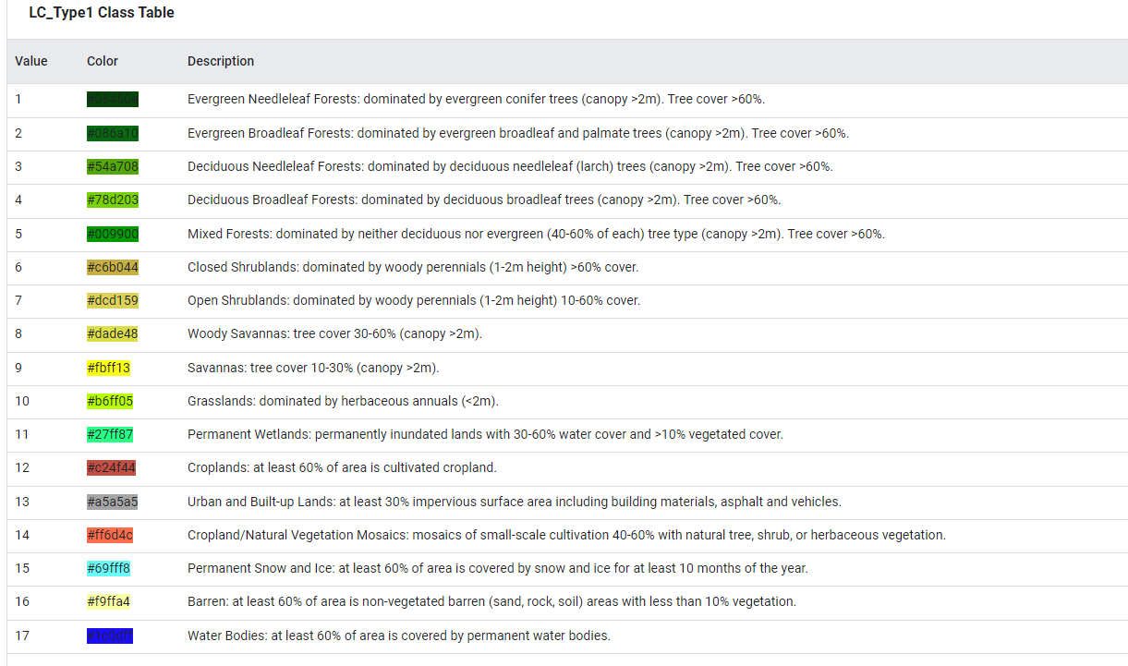

Fig 8 LC_Type 1 Class table

In this Modis Land Cover Data Set there are 17 classes for first land cover classification.where 12 and 14 represent the cropland and cropland/natural vegetation cover. In second LC_type_2 for the same 12 and 14 values represents cropland and vegetation. But we will be using Land cover classification type 1 i.e. IGBP classification. The UMD classification scheme ( LC_type_2) had 14 classes which were simplified from the original 17 IGBP land cover classes. In the UMD scheme, the crop-natural vegetation mosaic and wetlands were not included and the class of snow and ice was collapsed into the barren class.

**2.2.4 MOD13Q1.061 Terra Vegetation Indices 16-Day Global 500m:**[**(Link**](https://developers.google.com/earth-engine/datasets/catalog/MODIS_061_MOD13A1#description)**)**

The MOD13A1 V6.1 product provides a Vegetation Index (VI) value at a per pixel basis. There are two primary vegetation layers. The first is the Normalized Difference Vegetation Index (NDVI) which is referred to as the continuity index to the existing National Oceanic and Atmospheric Administration-Advanced Very High Resolution Radiometer (NOAA-AVHRR) derived NDVI. The second vegetation layer is the Enhanced Vegetation Index (EVI) that minimizes canopy background variations and maintains sensitivity over dense vegetation conditions. The EVI also uses the blue band to remove residual atmosphere contamination caused by smoke and sub-pixel thin cloud clouds. The MODIS NDVI and EVI products are computed from atmospherically corrected bi-directional surface reflectances that have been masked for water, clouds, heavy aerosols, and cloud shadows.

**2.2.5 MODIS Terra Daily NDWI: (**[**Link**](https://developers.google.com/earth-engine/datasets/catalog/MODIS_MOD09GA_006_NDWI#:~:text=The%20Normalized%20Difference%20Water%20Index,value%20from%20%2D1.0%20to%201.0)**)**

The ”MODIS Terra Daily 16-Day NDWI” refers to a product generated by combining MODIS data over a 16-day period to calculate the Normalized Difference Water Index (NDWI)[3]. This index is sensitive to changes in liquid water content within vegetation canopies and is derived from Near-Infrared (NIR) and Infrared (IR) bands. The product provides valuable information about water dynamics in vegetation-covered areas over a relatively short time frame. This product is generated from the MODIS/006/MOD09GA surface reflectance composites.

**Methodology :**

1. **Precipitation Extraction :**

**1.1. Data Collection and Preprocessing:**

* The shapefile contains all the information about each district. The shapefiles contain information like STATE_NAME , DISTRICT, ID , ID_RAIN , DIST_IMD , GEOMETRY. District boundary shapefiles for Parbhani, Bidar, Gulbarga, Balangir, and Ananthapur were obtained. The geometry in shapefile tells about the boundary of the that particular district where it contains the district is multipolygon or not with all the points latitude and longitude.

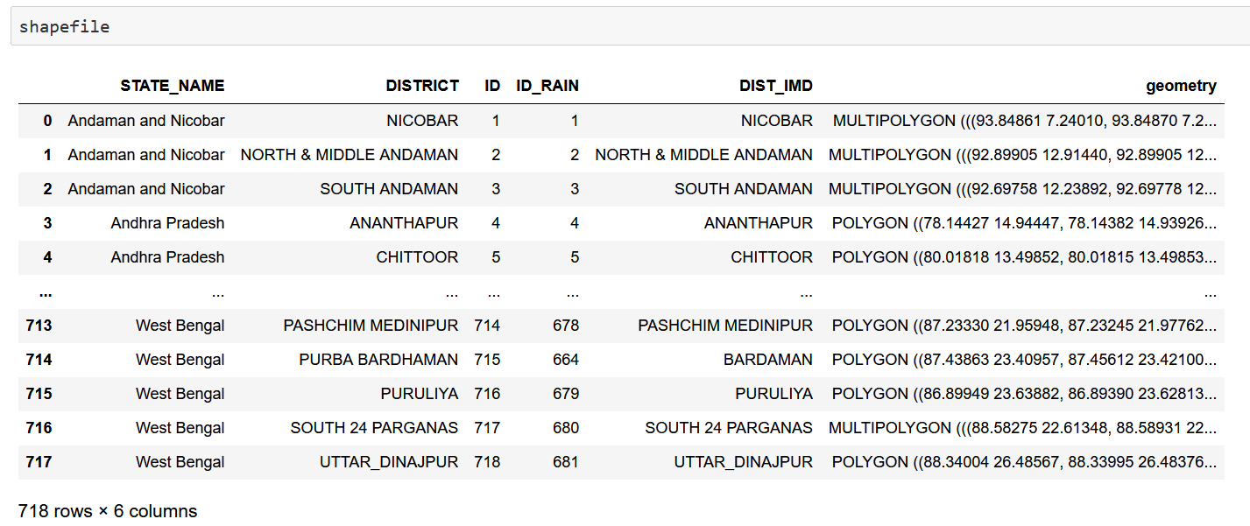

Fig 9. Shape files information

* The boundaries were plotted to visually inspect the geographical extent of the districts. For example, a district : Parbhani

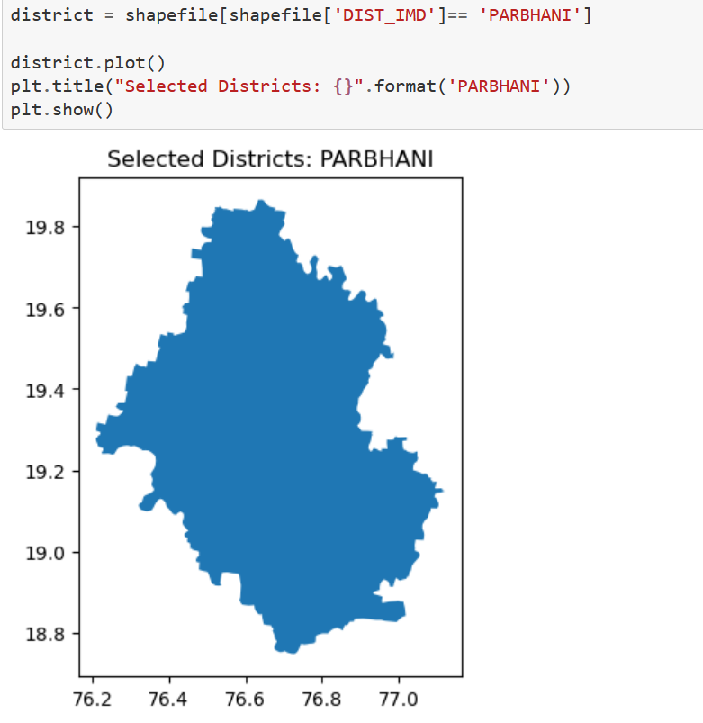

Fig 10: the Parbhani district Shape file

* Similarly we have got the boundary of our region of Interest ( Balangir , Ananthapur , Bidar , Parbhani , Gulbarga)
* Rainfall data for each district was extracted from the Indian Meteorological Department (IMD) dataset. The data covered multiple years from 1990 to 2023.

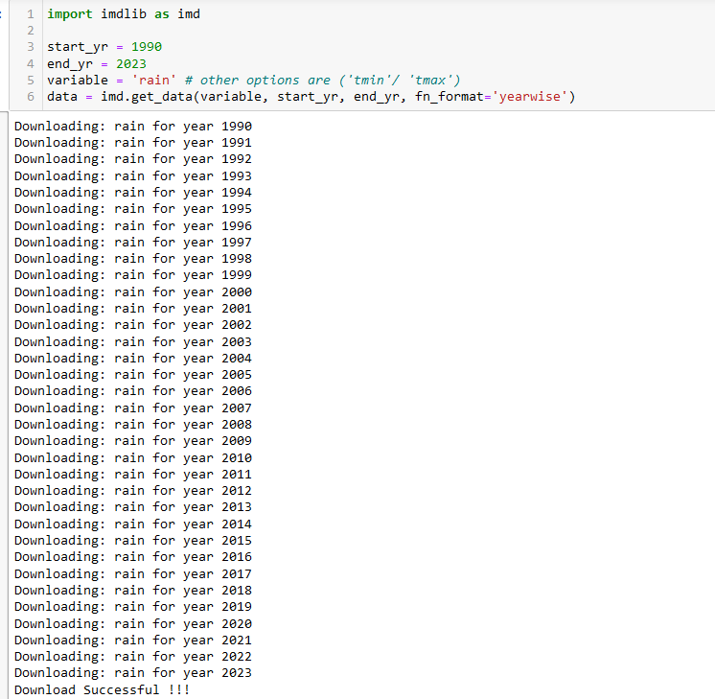

Fig 11: Using Imd library downloading the data

**1.2. Geospatial Analysis:**

* The exterior coordinates of the district boundaries were extracted to create region masks.
* Region masks were applied to the rainfall data to isolate precipitation values within each district's boundary.

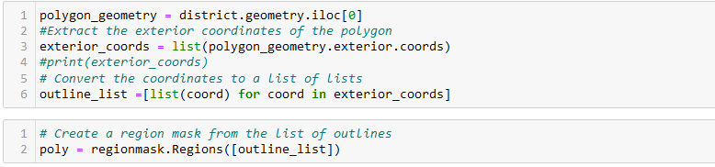

Fig 12: Region masking code snippet

* Monthly average rainfall values were calculated for each district across all the years in the dataset.

**1.3. Data Analysis:**

* Monthly average rainfall values were aggregated to calculate the overall average precipitation for each month across all the years.
* These values provided insights into the typical precipitation patterns within each district over the study period.
* The obtained monthly average rainfall values were analyzed to understand the seasonal variation and distribution of precipitation in each district.
* Calculated the cumulative sum of precipitation for every year (1990-2023) from June to September for the districts Balangir (Odisha) and Ananthapur (Andhra Pradesh) ,Parbhani (Maharashtra)
* The cumulative sum was calculated as the sum of actual values for each year.
* Calculated the seasonal normals for the respective districts. The normal values represent the average cumulative sum over the study period.
* Seasonal Normal was the average of the Cumulative sum over the 33 years.
* Calculated the deviation of the cumulative sums from the seasonal normals for both the districts.
* The deviation is computed as ((actual - normal) /normal) * 100 and is indicated in terms of percentage.
* **Positive deviations suggest above-normal precipitation**, while **negative deviations indicate below-normal precipitation, potentially signaling drought-like conditions.**

**1.4. Data Reporting:**

* The calculated monthly average rainfall values were tabulated and presented in the form of a DataFrame.
* As an example a CSV file named "Parbhani.csv" was generated to store the tabulated data for further reference and analysis.
* Similarly we have extracted for other five districts. For example Parbhani

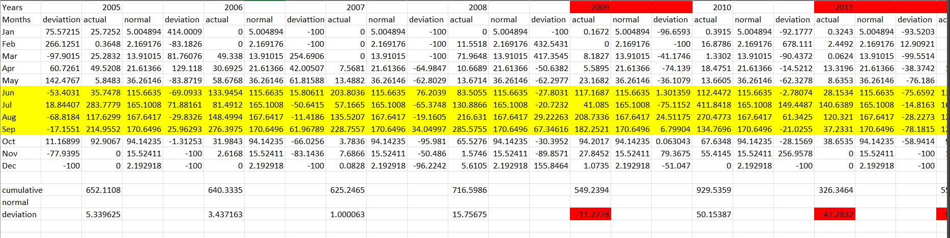

Fig 13. : Precipitation Calculation for Parbhani district

**1.5 Deviation Values for all the years in ascending order:**

After calculating the deviation for all the years for each district, we have kept all the percent deviation values for all the years in a CSV format.

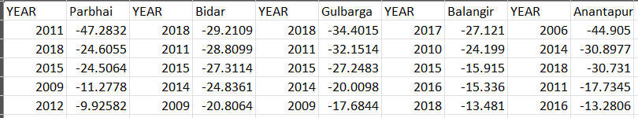

Fig.14 : Format of the CSV

For the calculation we are taking the 2 deficit years , 1 normal year, and 2 excessive years of a particular district.

**2. Satellite Images Data Extraction:**

**2.1 Land Cover Data Extraction:**

The objective is to extract land cover information from MODIS satellite imagery for the years 2009 to 2022 within a defined region of interest.

**2.1.1 Data Collection:**

* Obtain MODIS land cover data for the specified time period. This dataset is typically available through the Google Earth Engine platform, providing access to a vast array of remote sensing data.
* Define a region of interest (ROI) within which the land cover information will be extracted. This ROI can be delineated based on geographical coordinates or shapefiles representing the area of interest.

**2.1.2 Preprocessing:**

Clip the MODIS land cover images to the defined ROI to focus the analysis on the specific geographic area of interest. This ensures that only relevant data are processed and exported.

**2.1.3 Iteration:**

* Iterate through each image in the MODIS land cover collection covering the years 2009 to 2022.
* Extract the acquisition year from the image metadata to identify the temporal extent of each image.

**2.1.4 Export:**

* For each image, export the clipped land cover layer as a GeoTiff file. This file format is widely supported and can be easily imported into various GIS software for further analysis and visualization.
* Exported files are stored in a designated folder structure within Google Drive to facilitate organization and accessibility.

**2.1.5 Scale and Coordinate Reference System (CRS):**

* Specify the scale (resolution) of the exported GeoTiff files, typically in meters, to ensure consistency and compatibility with other spatial datasets.
* Define the Coordinate Reference System (CRS) for the exported files, such as EPSG:4326 (WGS84), to ensure proper georeferencing and alignment with other spatial data layers.

**2.1.6 Execution:**

* Execute the code within the Google Earth Engine environment. This platform provides the computational resources necessary to process large-scale remote sensing datasets efficiently.

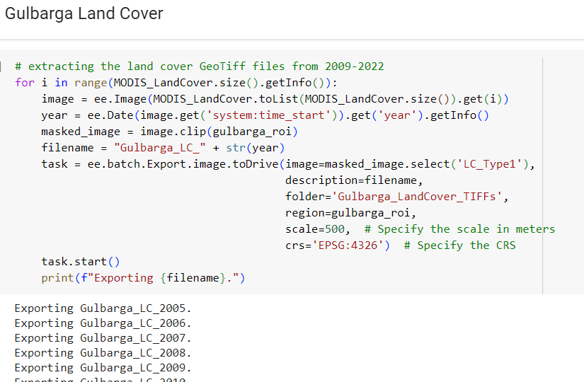

Fig 15: Modis Land Cover Satellite images Extraction

* Monitor the progress of the export tasks to ensure that all GeoTiff files are generated successfully.

**2.1.8 Validation:**

* Verify the exported GeoTiff files to ensure that they contain the expected land cover information for the specified years and geographic area.
* Perform visual inspection and data quality checks to assess the accuracy and reliability of the extracted land cover information.

**2.2 NDVI 16-Day Composite data Extraction:**

The objective is to extract MODIS NDVI (Normalized Difference Vegetation Index) data for the kharif season months (May to October) within a specified region. The data is extracted from Modis NDVI product data so the extracted data will already be 16 day composite data . It means we are getting image data in a 16 day gap.

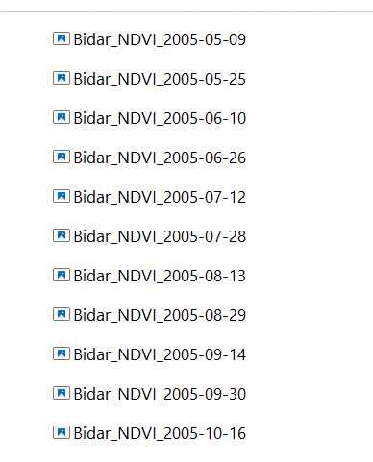

Fig 16: Structure of dates in 2005 year.

**2.2.1 Data Collection:** Retrieve MODIS NDVI data using the Google Earth Engine (GEE) platform. The dataset is selected based on its product identifier (MOD13A1) and filtered for the desired date range from 2005 to 2022.

**2.2.2 Preparation:**Define the kharif season months as May to October. This step identifies the months during which agriculture typically occurs in the study area.

**2.2.3 Iteration:**

* + Iterate through each image in the MODIS NDVI collection covering the specified date range.
  + Extract the date and month information from the image metadata to determine the temporal extent of each image. This step is crucial for filtering images corresponding to the kharif season months.

**2.2.4 Image Processing:**

Clip each NDVI image to the specified region of interest (ROI) using the clip() function. This step ensures that only data within the defined geographical area are retained for analysis.

**2.2.5 Export:**

* + For images corresponding to the kharif season months, export the clipped NDVI image as a GeoTiff file to Google Drive.
  + The exported files are organized into a designated folder ('Bidar_LandCover_TIFFs') within Google Drive for easy management and retrieval.

**2.2.6 Scale and Coordinate Reference System (CRS):**

* + Specify the scale (resolution) of the exported GeoTiff files as 500 meters to ensure consistency with spatial analysis requirements.
  + Define the Coordinate Reference System (CRS) for the exported files as EPSG:4326 (WGS84) to ensure proper georeferencing and interoperability with other spatial datasets.

**2.2.7 Execution:**

* + Execute the script within the Google Earth Engine environment to process and export the NDVI data.
  + Monitor the export tasks to ensure successful completion and troubleshoot any potential issues that may arise during execution.

**2.2.8 Validation:**

* + Verify the exported GeoTiff files to confirm that they contain the expected NDVI data for the kharif season months within the study area.
  + Conduct visual inspection and quality checks to assess the accuracy and suitability of the extracted NDVI information for further analysis

**2.2.9 Standardization:**

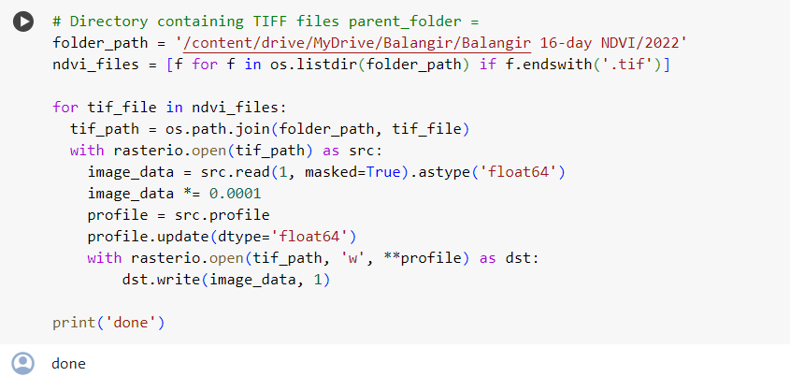

Fig 17: Standardizing the NDVI indices values

The NDVI indices values we are getting range -2000 to 10000. We have to standardize the value to make it in the range of -1 to 1.

**2.3 NDWI daily Data Extraction:**

The objective is to extract MODIS NDWI (Normalized Difference Water Index) data for the kharif season months (May to October) within a specified region for all the years from 2005 to 2006 . For each year Each month we will be getting daily data .

**2.3.1.Data Collection:**

Retrieve MODIS NDWI data using the Google Earth Engine (GEE) platform. The dataset is selected based on its product identifier (MCD43A4_006_NDWI) and filtered for the desired date range (from May 9 to November 1, 2005).

**2.3.2. Preparation:**

Define the kharif season months as May to October, which typically coincide with the monsoon period and significant water availability in the study area.

**2.3.3 Iteration:**

* Iterate through each image in the MODIS NDWI collection covering the specified date range.
* Extract the date and month information from the image metadata to determine the temporal extent of each image. This step facilitates filtering images corresponding to the kharif season months.

**2.3.4 Image Processing:**

For images corresponding to the kharif season months, clip each NDWI image to the specified region of interest (ROI) using the clip() function. This step ensures that only data within the defined geographical area are retained for analysis.

**2.3.5 Export:**

* Export the clipped NDWI images as GeoTiff files to Google Drive.
* Each exported file is named based on the date of acquisition to maintain temporal information.
* The exported files are organized into a designated folder ('Gulbarga_NDWI_TIFFs') within Google Drive for easy management and retrieval.

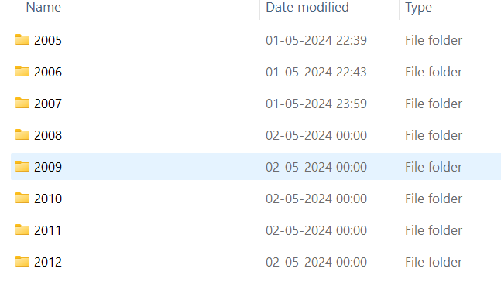

Fig 18 : Creation of folder for each of the year.

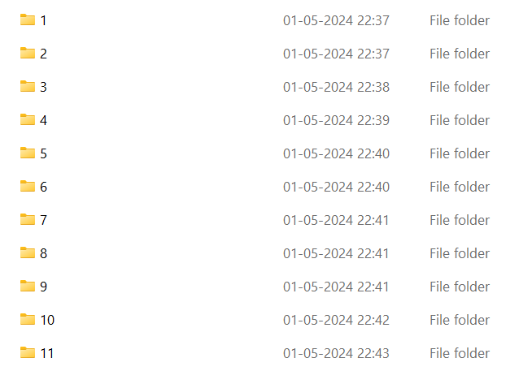

Fig 19 : 11 folder creation in each year

Each of the year has 11 folders which include 16 daily images each.

**2.3.6 Scale and Coordinate Reference System (CRS):**

* Specify the scale (resolution) of the exported GeoTiff files as 500 meters to ensure consistency with spatial analysis requirements.
* Define the Coordinate Reference System (CRS) for the exported files as EPSG:4326 (WGS84) to ensure proper georeferencing and interoperability with other spatial datasets.

**2.3.7 Execution:**

* Execute the script within the Google Earth Engine environment to process and export the NDWI data.
* Monitor the export tasks to ensure successful completion and address any potential issues during execution.

**2.3.8 Validation:**

* Verify the exported GeoTiff files to confirm that they contain the expected NDWI data for the kharif season months within the study area.
* Conduct visual inspection and quality checks to assess the accuracy and suitability of the extracted NDWI information for further analysis.

**3. Agricultural Masking:**

1. **NDVI & Land Cover:**

As we have downloaded the dataset from the Modis terra vegetation 16 days composite data. And our goal is to get the values of NDVI from those pixels where it shows the agricultural area. To get these pixel values we are performing agricultural masking.The following code shows how we are doing the masking.

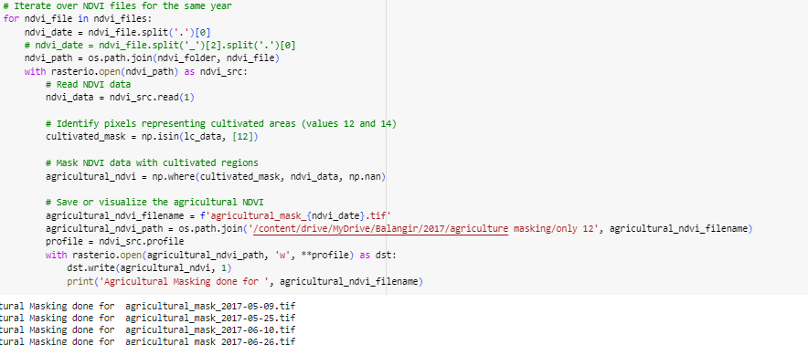

Fig 20. The code snippet of how the masking is done

|  |  |  |  |  |  |
| --- | --- | --- | --- | --- | --- |
|  |  |  |  |  |  |
|  |  |  |  |  |  |

Fig 21 : NDVI raster images of Balangir on 2017

1. **NDWI & Land Cover:**

Similar process has been done to get the NDWI indices values from the interested cropland area pixel values. After getting 16 days composite data from the daily data. We are performing the agricultural masking to get the NDWI values.

|  |  |  |  |  |  |
| --- | --- | --- | --- | --- | --- |
|  |  |  |  |  |  |
|  |  |  |  |  |  |

Fig 22 : NDWI raster images of Balangir on 2017

**4. NDDI Calculation & Raster generation:**

As previously mentioned, how to calculate the NDDI index. Referring to that formula using the values of NDVI and NDWI . We are calculating the NDDI index. From the Indices values have to generate the raster of NDDI.

For Each we will get 11 raster for each year's similar dates with NDVI and NDWI.

|  |  |  |  |  |  |
| --- | --- | --- | --- | --- | --- |
|  |  |  |  |  |  |
|  |  |  |  |  |  |

Fig : NDDI raster of Balangir district of 2017

**5. Zonal Statistics Run:**

To get the statistics of all the indices NDVI and NDWI and NDDI we had to run. Zonal Statistics. A zonal statistics operation is one that calculates statistics on cell values of a raster (a value raster) within the zones defined by another dataset.

For Example values of three different indices are :

|  |  |  |
| --- | --- | --- |
| NDVI zonal mean year 2017 : | NDWI Zonal mean Year 2017: | NDDI Zonal Mean Year 2017: |

Fig 23 : Zonal Mean of Each Indices

**Result :**

For each district Parbhani, Balangir, Ananthapur, Bidar, Gulbarga we have shown how the NDVI , NDWI, NDDI raster are appearing respectively.

**Table: Parbhani District (2011)**

|  |  |  |  |  |  |
| --- | --- | --- | --- | --- | --- |
|  |  |  |  |  |  |
|  |  |  |  |  |  |

NDVI Raster Images

|  |  |  |  |  |  |
| --- | --- | --- | --- | --- | --- |
|  |  |  |  |  |  |
|  |  |  |  |  |  |

NDWI Raster Images

|  |  |  |  |  |  |
| --- | --- | --- | --- | --- | --- |
|  |  |  |  |  |  |
|  |  |  |  |  |  |

NDDI Raster Images

**Balangir District(2017)**

|  |  |  |  |  |  |
| --- | --- | --- | --- | --- | --- |
|  |  |  |  |  |  |
|  |  |  |  |  |  |

NDWI Raster Images

|  |  |  |  |  |  |
| --- | --- | --- | --- | --- | --- |
|  |  |  |  |  |  |
|  |  |  |  |  |  |

NDWI Raster Images

|  |  |  |  |  |  |
| --- | --- | --- | --- | --- | --- |
|  |  |  |  |  |  |
|  |  |  |  |  |  |

NDWI Raster Images

**Anantapur District(2006)**

|  |  |  |  |  |  |
| --- | --- | --- | --- | --- | --- |
|  |  |  |  |  |  |
|  |  |  |  |  |  |

NDDI Raster Images

|  |  |  |  |  |  |
| --- | --- | --- | --- | --- | --- |
|  |  |  |  |  |  |
|  |  |  |  |  |  |

NDDI Raster Images

|  |  |  |  |  |  |
| --- | --- | --- | --- | --- | --- |
|  |  |  |  |  |  |
|  |  |  |  |  |  |

NDDI Raster Images

**Bidar District(2011)**

|  |  |  |  |  |  |
| --- | --- | --- | --- | --- | --- |
|  |  |  |  |  |  |
|  |  |  |  |  |  |

NDVI Raster Images

|  |  |  |  |  |  |
| --- | --- | --- | --- | --- | --- |
|  |  |  |  |  |  |
|  |  |  |  |  |  |

NDWI Raster Images

|  |  |  |  |  |  |
| --- | --- | --- | --- | --- | --- |
|  |  |  |  |  |  |
|  |  |  |  |  |  |

NDVI Raster Images

**Gulbarga District(2018)**

|  |  |  |  |  |  |
| --- | --- | --- | --- | --- | --- |
|  |  |  |  |  |  |
|  |  |  |  |  |  |

NDVI Raster Images

|  |  |  |  |  |  |
| --- | --- | --- | --- | --- | --- |
|  |  |  |  |  |  |
|  |  |  |  |  |  |

NDWI Raster Images

|  |  |  |  |  |  |
| --- | --- | --- | --- | --- | --- |
|  |  |  |  |  |  |
|  |  |  |  |  |  |

NDDI Raster Images

**Interpretation:**

* For each Study area, the years were discriminated into years with Normal, Deficient, and Excess precipitation.
* The years were discriminated against on the basis of **IMD Criteria**. When the percent deviation value lies between -19 to +19, then corresponding year is considered as year with Normal precipitation. If the percent deviation is above +19, then the year is having Excess precipitation and if the deviation values are less than -19, then the year is considered to experience Deficient precipitation.
* So, we identify the Normal, Deficient, and Excess years for all the study areas. We identify the year 2017 as a deficient year for Balangir district.
* As the blue patches in the NDDI raster image increase, it indicates that there is positive percent precipitation deviation.
* Throughout the year 2017, we can see the blue patches in the raster decreasing, which implies that the percent precipitation deviation is moving towards the negative direction.
* Also, the yellow patches indicate areas of deficient rainfall and areas having dry spells.
* Throughout the year 2017, the yellow patches increase, which indicate increase in areas of moderate to severe drought-like conditions.
* For Gulbarga District, 2018 is one the rain deficient year . Throughout the year 2018 , We can see the Blue patches are slightly visible throughout the raster. Which means in 2018 the percentage of precipitation i s also moving towards a negative direction.The yellow patches also decrease with time. But At the time of September there are huge yellow patches which indicate deficient rainfall.
* For Parbhani District , 2011 is one of the rain deficient years as we discriminated the year from IMD criteria. In the year 2011 , we can see the huge yellow patch beginning at the time of June. then the patches decrease with time.
* Similarly for Bidar District, we can see for the year 2011 at the time of october a huge yellow patch.
* For Ananthapur district we can see the huge yellow patches throughout the months of June to October in 2006.